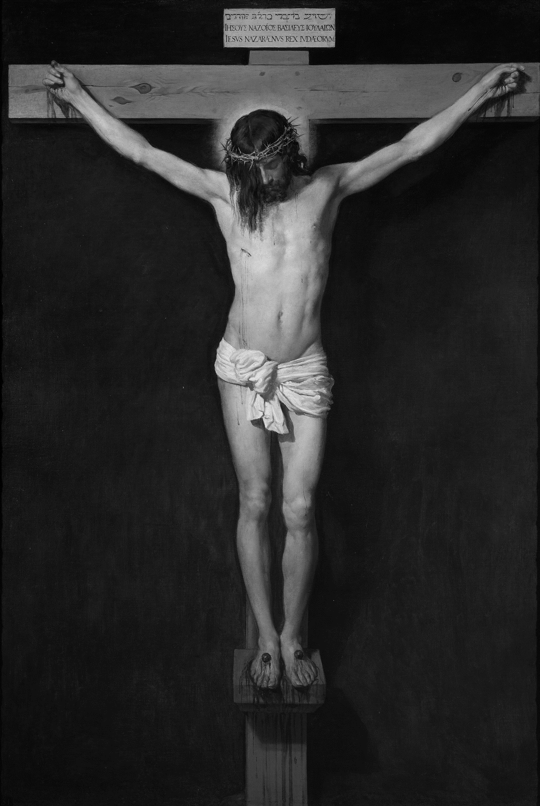
HOLY WEEK SCHEDULE
SAINT MATTHEW CHURCH

SUNDAY, MARCH 28 – PALM SUNDAY
Normal weekend Mass schedule
Blessing of Palms at all weekend Masses
Solemn Procession at Sunday Mass

MONDAY, MARCH 29 –MONDAY OF HOLY WEEK
Mass – 6:30 PM

TUESDAY, MARCH 30 –TUESDAY OF HOLY WEEK
Mass – 8:30 AM
Chrism Mass – 7:00 PM @ Cathedral Basilica in Covington (Live Online)

WEDNESDAY, MARCH 31 – SPY WEDNESDAY
Mass – 6:30 PM
Confessions – 5:30-6:20 PM

THURSDAY, APRIL 1 – HOLY THURSDAY
Mass of the Lord’s Supper – 6:30 PM
Adoration in church until midnight

FRIDAY, APRIL 2 – GOOD FRIDAY
Stations of the Cross – 3:00 PM
Solemn Liturgy of the Lord’s Passion – 6:00 PM
Confessions – after the Liturgy until no more people in line

SATURDAY, APRIL 3 – HOLY SATURDAY
Confessions – 3:00-5:00 PM
NO 5:00 PM MASS
Easter Vigil Mass – 8:30 PM

SUNDAY, APRIL 4 – EASTER SUNDAY
Mass @ 9:00 AM

Please join us as we commemorate this week of suffering and salvation.

